Control Lesson 3

1. [1. Sebastian Introduction](https://classroom.udacity.com/nanodegrees/nd787/parts/3619d672-ce5b-4a29-8a15-172cb667b5bb/modules/b78ec22c-5afe-444b-8719-b390bd2b2988/lessons/adf9cc77-d52c-4958-810d-89ddc5997437/concepts/074c4810-0052-4955-a184-5045aa7c6387)

<https://www.youtube.com/watch?time_continue=2&v=tS9oGNg4oLY>

1. [2. Intro to 2D Dynamics](https://classroom.udacity.com/nanodegrees/nd787/parts/3619d672-ce5b-4a29-8a15-172cb667b5bb/modules/b78ec22c-5afe-444b-8719-b390bd2b2988/lessons/adf9cc77-d52c-4958-810d-89ddc5997437/concepts/2717b209-bc1a-4661-b348-e2fb9d623ac7)

<https://www.youtube.com/watch?v=DsSlWKIJ4sk>

1. [3. Underactuation](https://classroom.udacity.com/nanodegrees/nd787/parts/3619d672-ce5b-4a29-8a15-172cb667b5bb/modules/b78ec22c-5afe-444b-8719-b390bd2b2988/lessons/adf9cc77-d52c-4958-810d-89ddc5997437/concepts/d9528297-f4c6-464d-8e68-9b77e8634d5b)

<https://www.youtube.com/watch?v=Q6dJA8HhAWU>

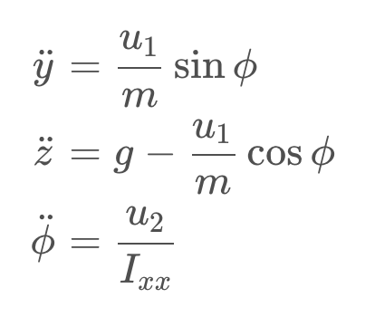

Since a 2D drone only has two control inputs, we can only simultaneously control two of its three degrees of freedom.

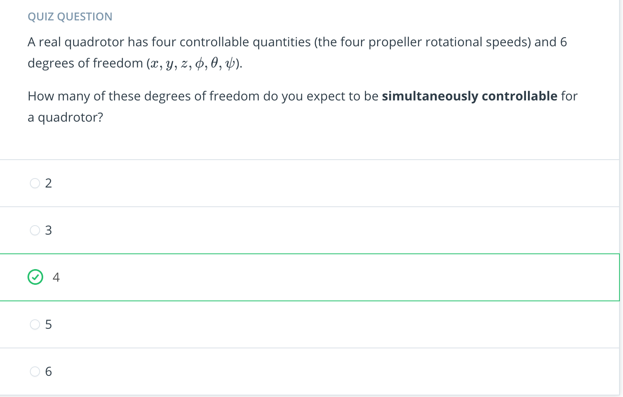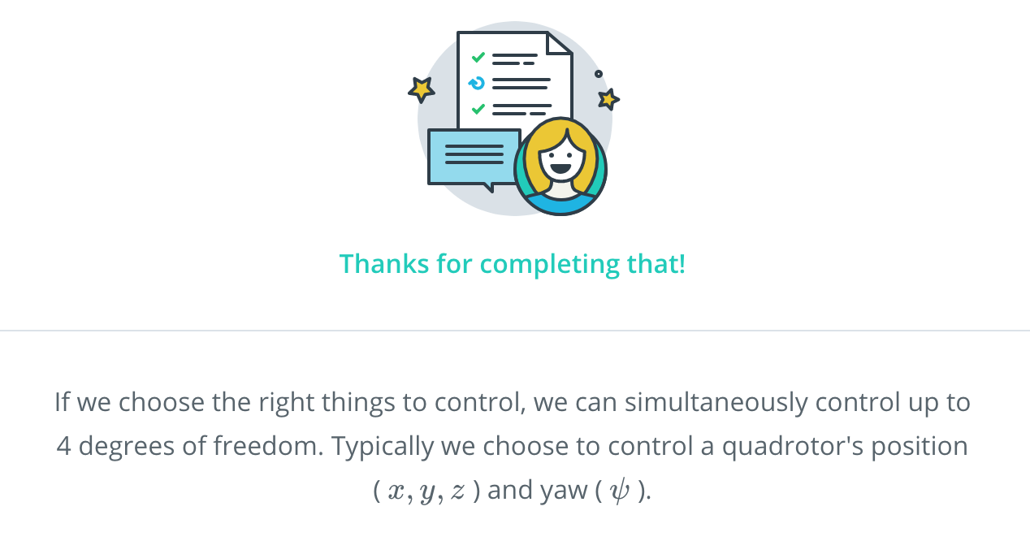

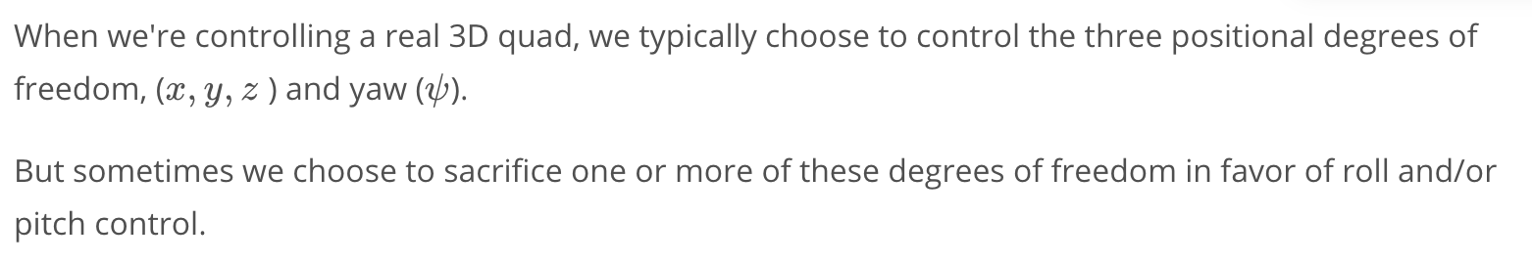

Take a look at [this video](https://www.youtube.com/watch?v=MvRTALJp8DM&feature=youtu.be) for some interesting examples of maneuvers that require roll and/or pitch control.

1. [4. Coupling](https://classroom.udacity.com/nanodegrees/nd787/parts/3619d672-ce5b-4a29-8a15-172cb667b5bb/modules/b78ec22c-5afe-444b-8719-b390bd2b2988/lessons/adf9cc77-d52c-4958-810d-89ddc5997437/concepts/6bfcfd26-66a0-4b1e-b715-16fb8c992b9c)

<https://www.youtube.com/watch?v=jlDD-RVhK9g>

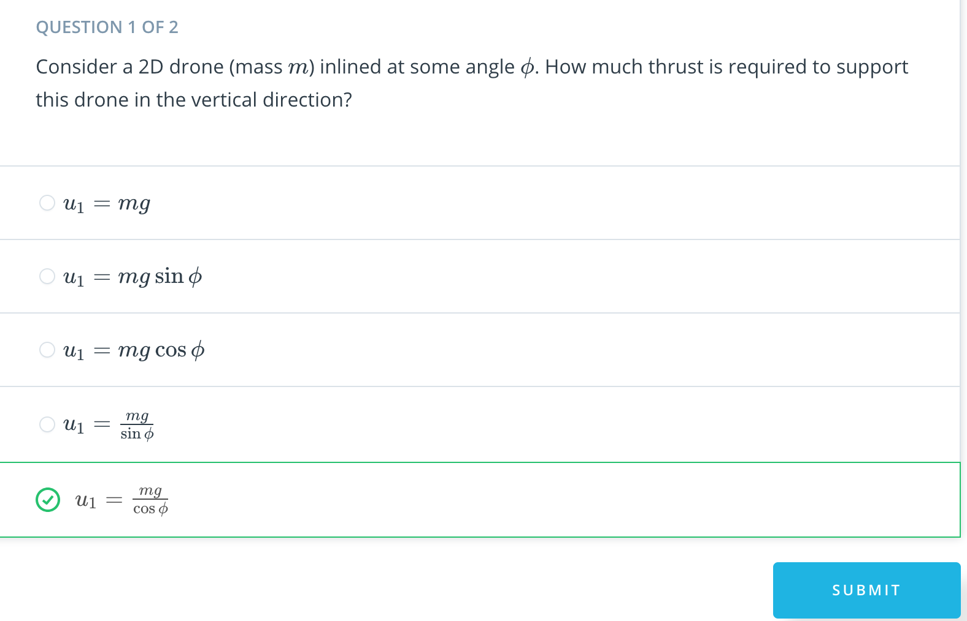

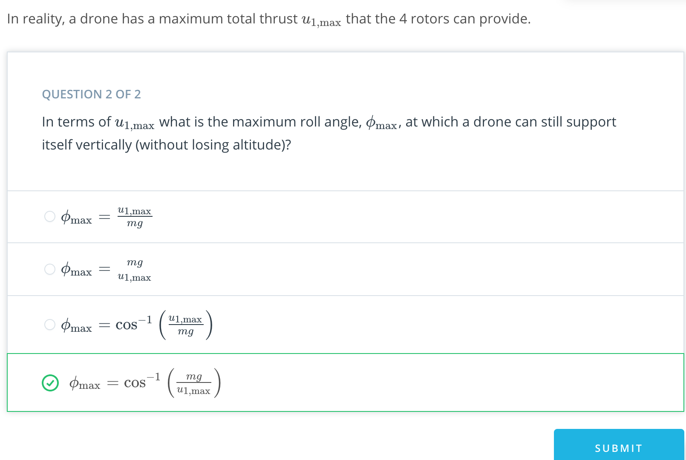

1. [5. Lesson Overview](https://classroom.udacity.com/nanodegrees/nd787/parts/3619d672-ce5b-4a29-8a15-172cb667b5bb/modules/b78ec22c-5afe-444b-8719-b390bd2b2988/lessons/adf9cc77-d52c-4958-810d-89ddc5997437/concepts/09435913-7a2a-40ef-a192-5e11db194e66)

<https://www.youtube.com/watch?v=3M7K5qC1zq0>

1. [6. Motivation for Linearization](https://classroom.udacity.com/nanodegrees/nd787/parts/3619d672-ce5b-4a29-8a15-172cb667b5bb/modules/b78ec22c-5afe-444b-8719-b390bd2b2988/lessons/adf9cc77-d52c-4958-810d-89ddc5997437/concepts/8dc3b06e-8cf8-42b9-928e-b2d407c4d66a)

<https://www.youtube.com/watch?time_continue=4&v=UmV-KSARONs>

1. [7. Linearization Math](https://classroom.udacity.com/nanodegrees/nd787/parts/3619d672-ce5b-4a29-8a15-172cb667b5bb/modules/b78ec22c-5afe-444b-8719-b390bd2b2988/lessons/adf9cc77-d52c-4958-810d-89ddc5997437/concepts/ffff7feb-2b7d-42f7-8feb-3ff3e2d95f0a)

<https://www.youtube.com/watch?time_continue=1&v=SgDcWJ8lS4c>

1. [8. Linearization Intuition 1](https://classroom.udacity.com/nanodegrees/nd787/parts/3619d672-ce5b-4a29-8a15-172cb667b5bb/modules/b78ec22c-5afe-444b-8719-b390bd2b2988/lessons/adf9cc77-d52c-4958-810d-89ddc5997437/concepts/9515a2f2-0275-4bf0-9e33-61f53a68e30a)

<https://www.youtube.com/watch?v=XBTgM0ibU2s>

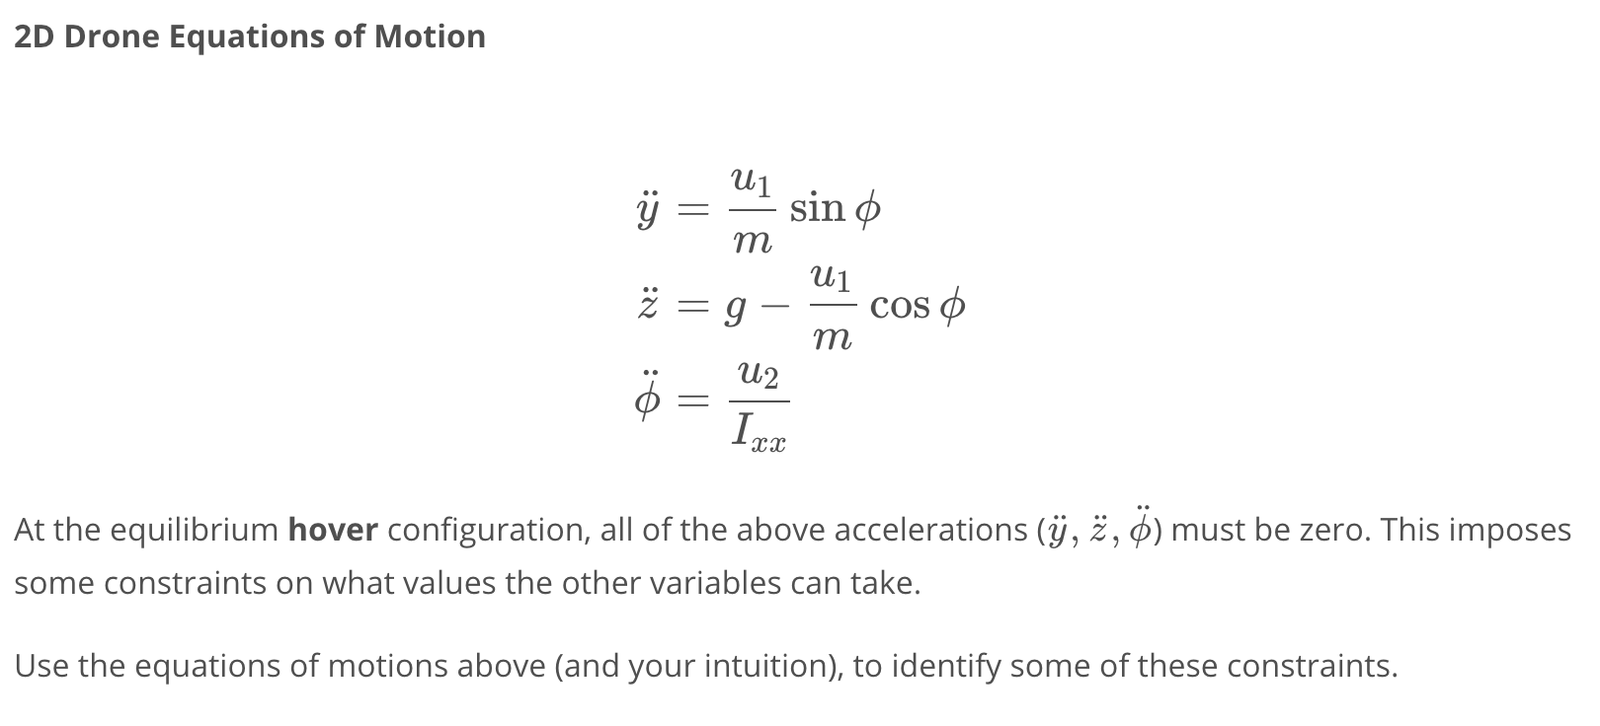

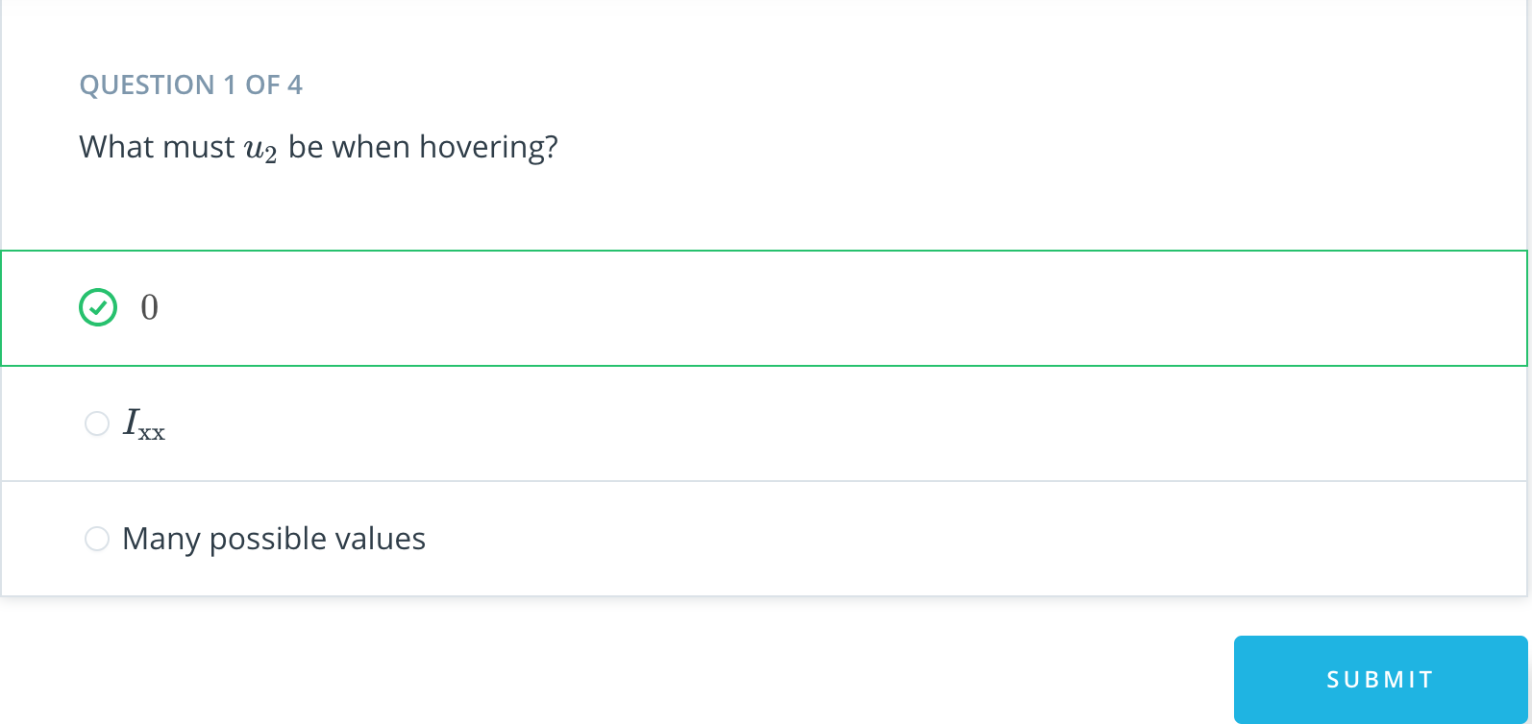

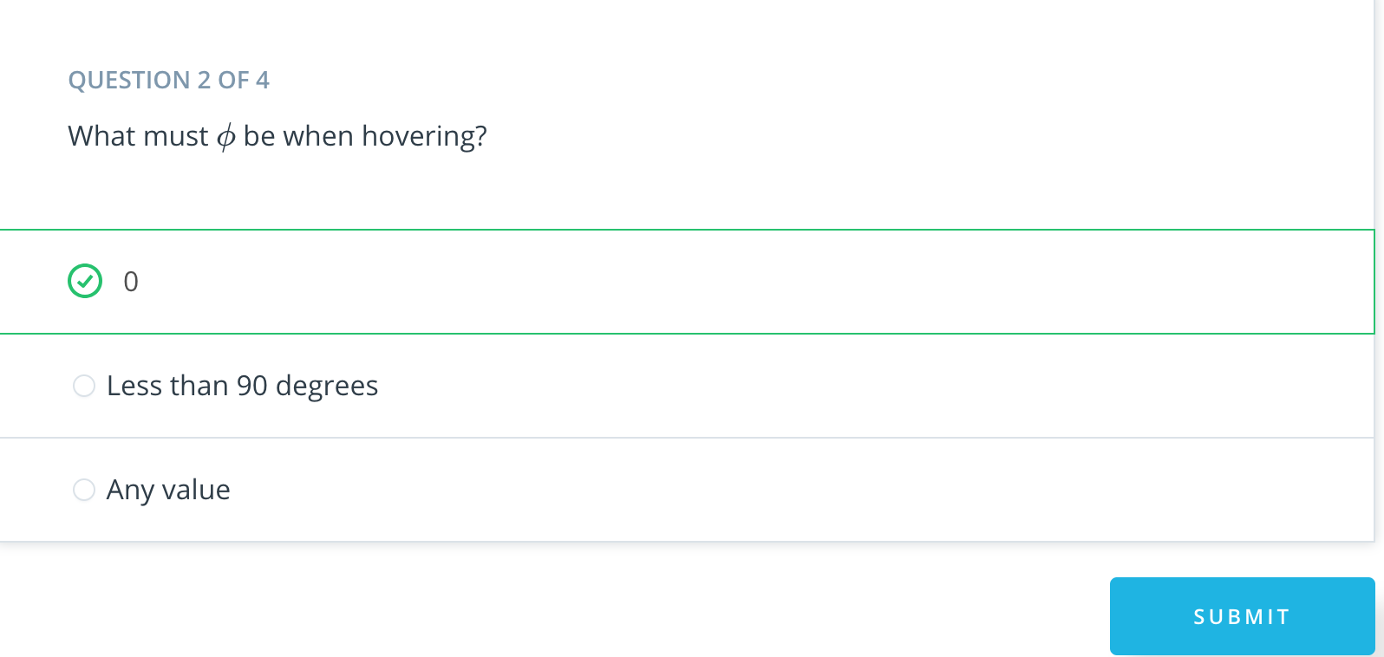

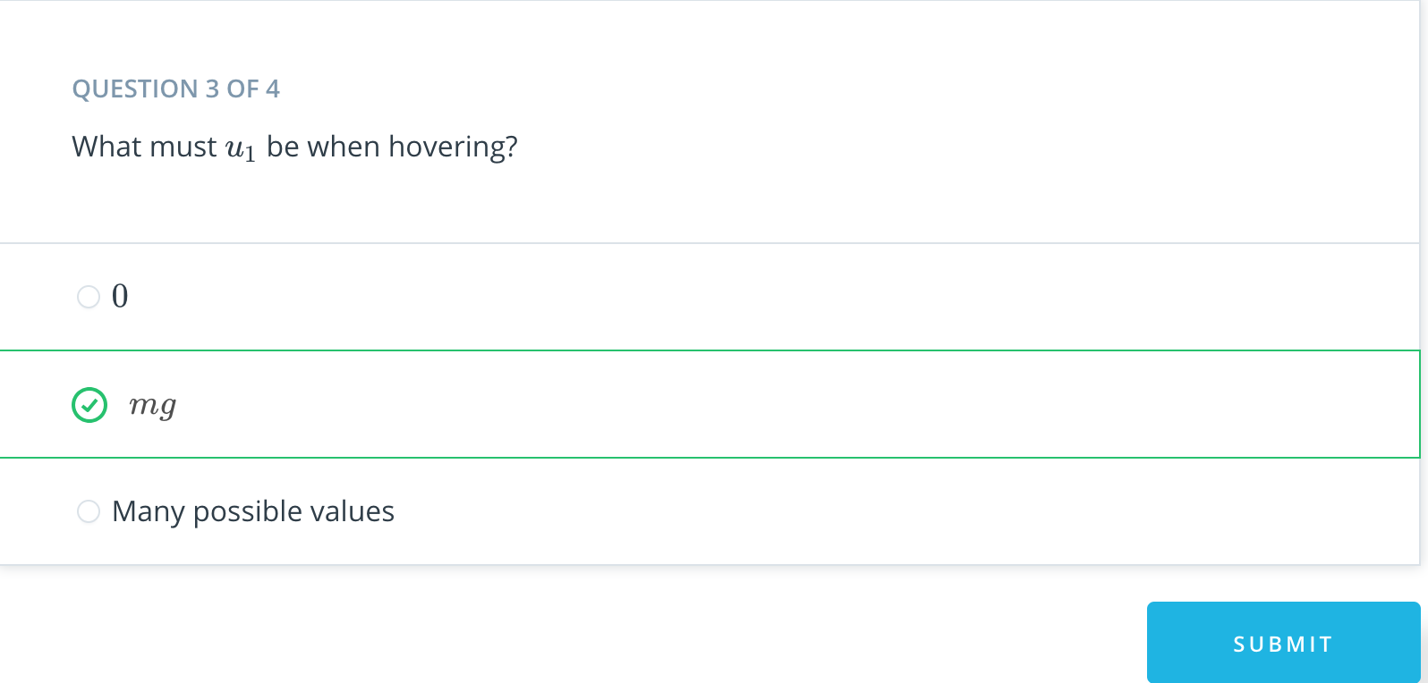

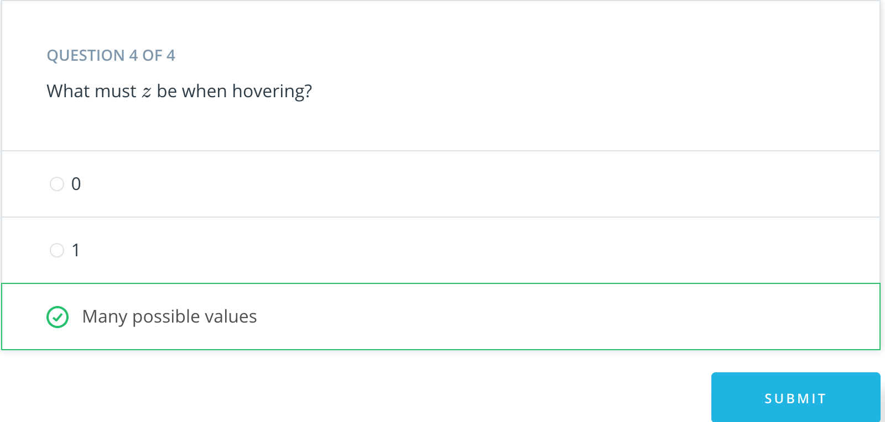

1. [9. Linearization Intuition 2](https://classroom.udacity.com/nanodegrees/nd787/parts/3619d672-ce5b-4a29-8a15-172cb667b5bb/modules/b78ec22c-5afe-444b-8719-b390bd2b2988/lessons/adf9cc77-d52c-4958-810d-89ddc5997437/concepts/94bda10a-702f-409b-81c9-d34771c98360)

<https://www.youtube.com/watch?time_continue=2&v=y5dUxtA_wC8>

1. [10. Linearization Intuition 3](https://classroom.udacity.com/nanodegrees/nd787/parts/3619d672-ce5b-4a29-8a15-172cb667b5bb/modules/b78ec22c-5afe-444b-8719-b390bd2b2988/lessons/adf9cc77-d52c-4958-810d-89ddc5997437/concepts/c1a422b4-f3cc-41f4-b7e1-6ee3d7677cf2)

<https://www.youtube.com/watch?v=dZTiI1n3F5E>

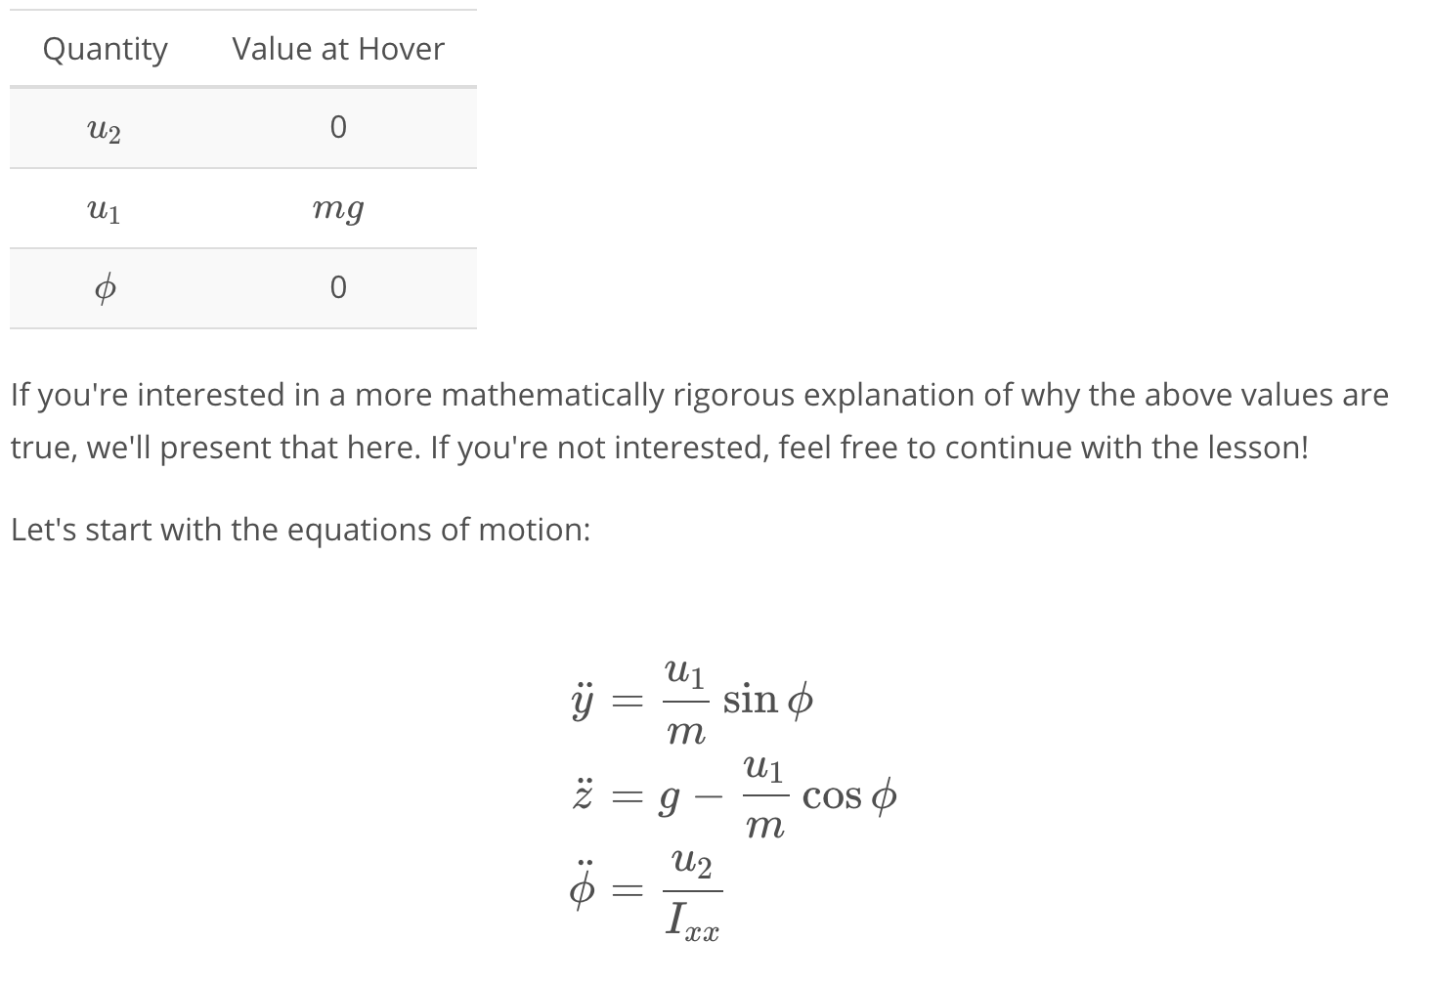

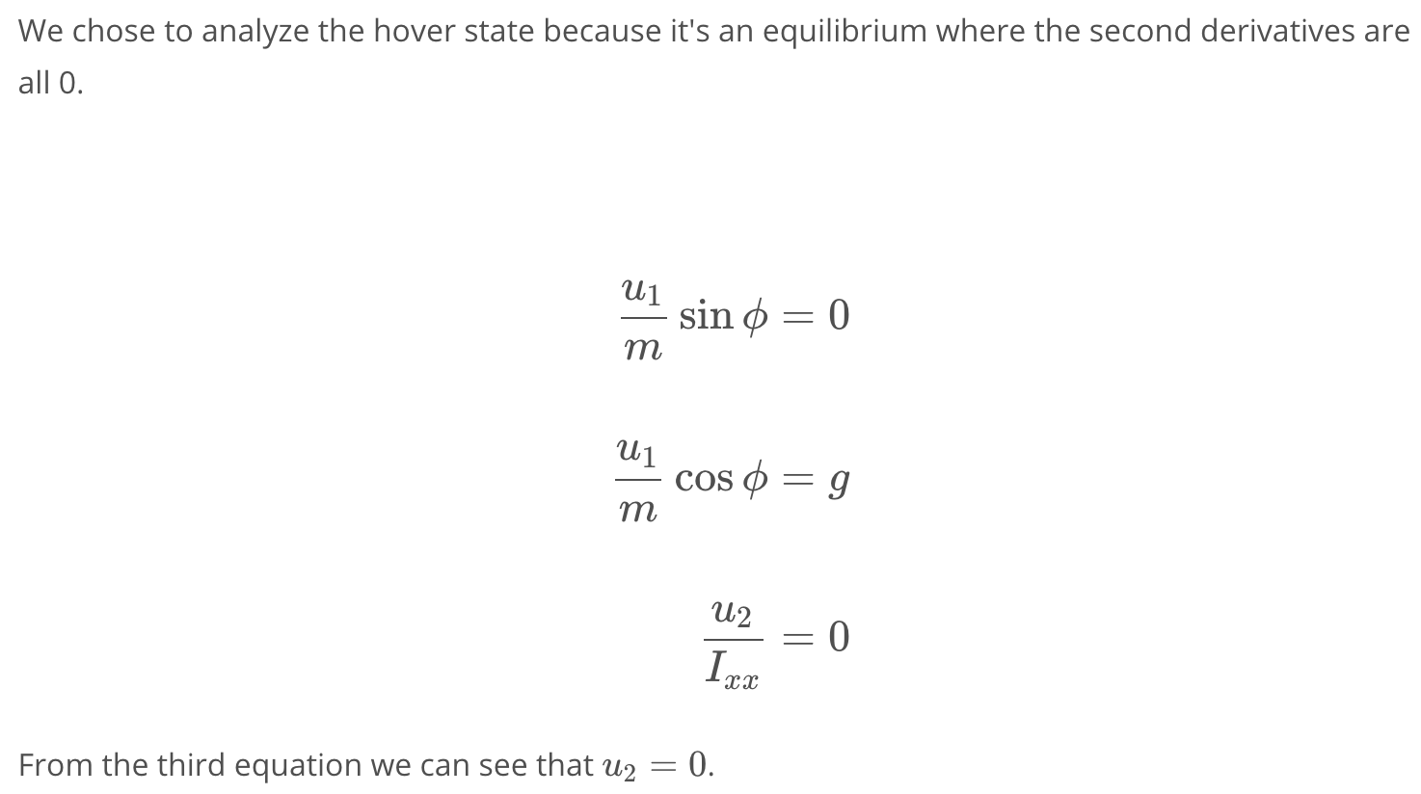

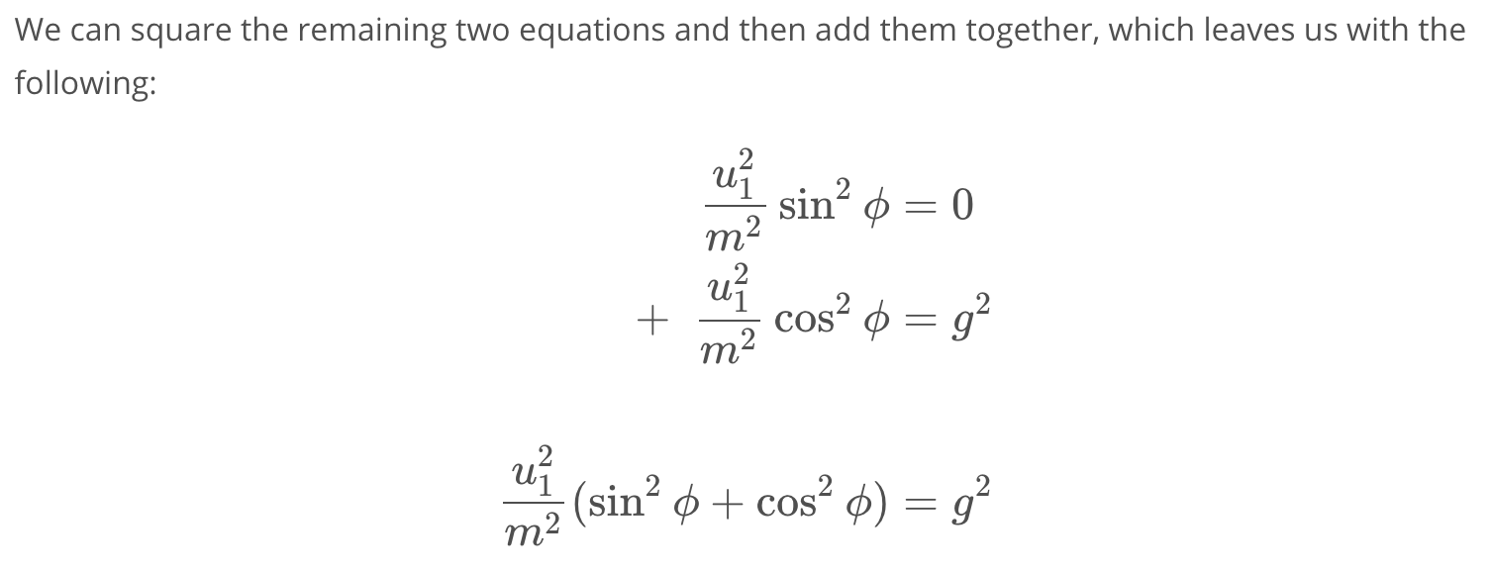

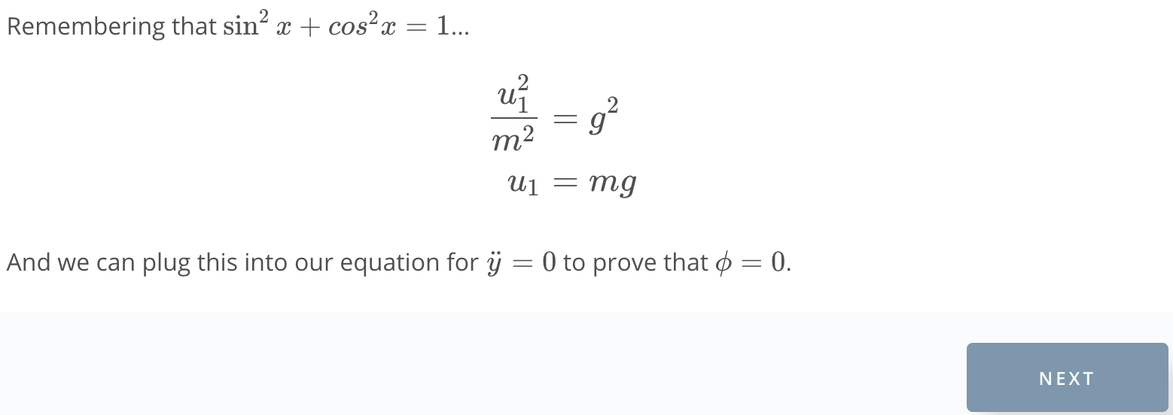

1. [11. Linearization Exploration Exercise](https://classroom.udacity.com/nanodegrees/nd787/parts/3619d672-ce5b-4a29-8a15-172cb667b5bb/modules/b78ec22c-5afe-444b-8719-b390bd2b2988/lessons/adf9cc77-d52c-4958-810d-89ddc5997437/concepts/459729d9-107b-4269-bee2-26c4fe2a0a12)

Linearization.ipynb

1. [12. Controlling Motion Near Hover](https://classroom.udacity.com/nanodegrees/nd787/parts/3619d672-ce5b-4a29-8a15-172cb667b5bb/modules/b78ec22c-5afe-444b-8719-b390bd2b2988/lessons/adf9cc77-d52c-4958-810d-89ddc5997437/concepts/e7a3bf01-bafd-4df5-8651-b325e61d4e27)

<https://www.youtube.com/watch?v=jgUZzCSXPm8>

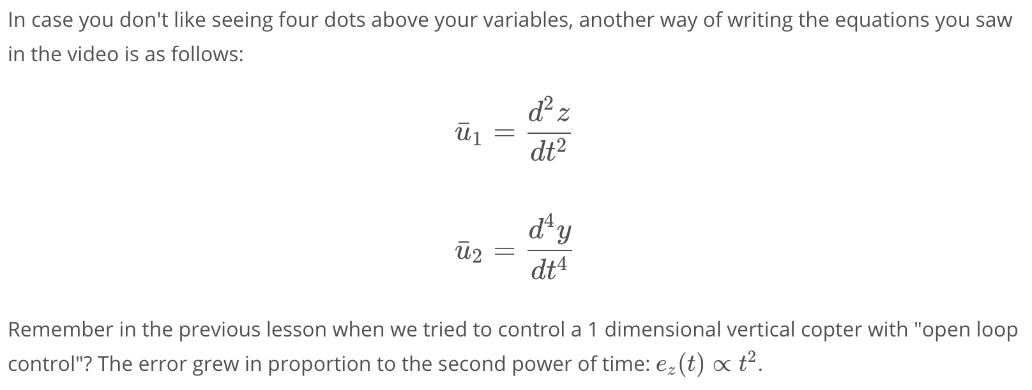

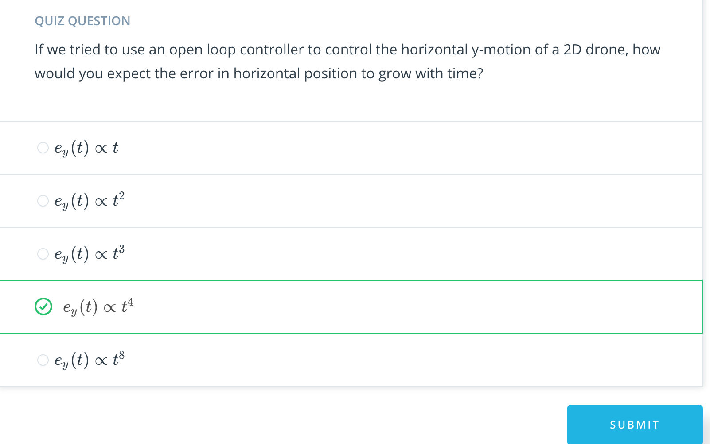

1. [13. Intro to Cascaded Control](https://classroom.udacity.com/nanodegrees/nd787/parts/3619d672-ce5b-4a29-8a15-172cb667b5bb/modules/b78ec22c-5afe-444b-8719-b390bd2b2988/lessons/adf9cc77-d52c-4958-810d-89ddc5997437/concepts/0261dae7-6409-4aac-84dc-0357ae2259a6)

<https://www.youtube.com/watch?time_continue=1&v=FzObnvshV7Q>

1. [14. Implement Linear Controller Exercise](https://classroom.udacity.com/nanodegrees/nd787/parts/3619d672-ce5b-4a29-8a15-172cb667b5bb/modules/b78ec22c-5afe-444b-8719-b390bd2b2988/lessons/adf9cc77-d52c-4958-810d-89ddc5997437/concepts/d353a32b-71f2-4524-8ac7-d4150a1572fa)

Linear Controller.ipynb

1. [15. Separation of Time Scales](https://classroom.udacity.com/nanodegrees/nd787/parts/3619d672-ce5b-4a29-8a15-172cb667b5bb/modules/b78ec22c-5afe-444b-8719-b390bd2b2988/lessons/adf9cc77-d52c-4958-810d-89ddc5997437/concepts/6e47f669-6120-49f0-bc04-86254143f879)

<https://www.youtube.com/watch?v=2jAAsCvufl0>

1. [16. Non-Linear Control](https://classroom.udacity.com/nanodegrees/nd787/parts/3619d672-ce5b-4a29-8a15-172cb667b5bb/modules/b78ec22c-5afe-444b-8719-b390bd2b2988/lessons/adf9cc77-d52c-4958-810d-89ddc5997437/concepts/449a2563-db72-44ab-be5b-74bcb7d4993e)

<https://www.youtube.com/watch?v=Tvu76GD8SyA>

1. [17. Implement Non-Linear Controller Exercise](https://classroom.udacity.com/nanodegrees/nd787/parts/3619d672-ce5b-4a29-8a15-172cb667b5bb/modules/b78ec22c-5afe-444b-8719-b390bd2b2988/lessons/adf9cc77-d52c-4958-810d-89ddc5997437/concepts/d28d2bc0-96d7-41df-9474-aa378dba787e)

Non-Linear Controller.ipynb

1. [18. Comparing Trajectories Exercise](https://classroom.udacity.com/nanodegrees/nd787/parts/3619d672-ce5b-4a29-8a15-172cb667b5bb/modules/b78ec22c-5afe-444b-8719-b390bd2b2988/lessons/adf9cc77-d52c-4958-810d-89ddc5997437/concepts/161d9886-4d1d-4033-87eb-5a4faa1958c5)

[Comparing Trajectories.ipynb](https://viewc966e973.udacity-student-workspaces.com/notebooks/Comparing%20Trajectories.ipynb)

1. [19. Summary](https://classroom.udacity.com/nanodegrees/nd787/parts/3619d672-ce5b-4a29-8a15-172cb667b5bb/modules/b78ec22c-5afe-444b-8719-b390bd2b2988/lessons/adf9cc77-d52c-4958-810d-89ddc5997437/concepts/ef6cc108-3adf-48fc-89ab-113b66d0fc63)

<https://www.youtube.com/watch?v=nRnULToP-jU>